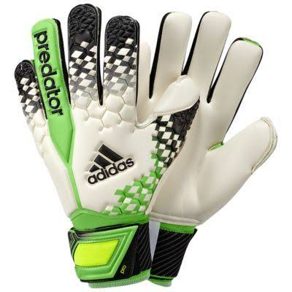

Football goalkeeper gloves High quality Random color

Rs. 400

* Goal keeper gloves
* High quality
* Full German ruber